**User’s Guide**

3.0

Extentrix Web Interface for Microsoft SharePoint 2013

# NOTICE

Extentrix Systems, makes no representations or warranties with respect to the contents or use of this publication. Extentrix specifically disclaims any express or implied warranties, merchantability, or fitness for any particular purpose. Extentrix reserves the right to make any changes in specifications and other information contained in this publication without prior notice and without obligation to notify any person or entity of such revisions or changes.

No part of this publication may be reproduced or transmitted in any form or by any means, electronic or mechanical, including photocopying, recording, or information and retrieval systems for any purpose other than the purchase’s personal use without express written permission of:

Extentrix Systems

P.O.Box 4404

Dubai, UAE

[http://www.extentrix.com](http://www.extentrix.com/)

**Copyright and Trademark Notice**

Information in this document is subject to change without notice. Companies, names, and data used in examples herein are fictitious unless otherwise noted. Other than printing one copy for personal use, no part of this document may be reproduced or transmitted in any form or by any means, electronic or mechanical, for any purpose, without the express written permission of Extentrix Systems.

Copyright © 2010 - 2019 Extentrix Systems, Inc. All rights reserved.

**Trademark Acknowledgements**

Citrix, ICA (Independent Computing Architecture), and XenApp are registered trademarks of Citrix in the United States and/or other countries.

Microsoft, Windows, Office, Internet Information Services, SharePoint, SQL Server, ActiveX, and Active Directory are either registered trademarks or trademarks of Microsoft Corp. in the United States and/or other countries.

All other trademarks and registered trademarks are the property of their owners.

Contents

NOTICE 2

How to use Extentrix Web Interface for Microsoft SharePoint 5

Content Redirection 7

Customizing the Appearance of the Web Part 8

To modify the appearance of the Web Part 8

About Extentrix 11

Figure 1: EWISP - Icons View 5

Figure 2: EWISP - List View 5

Figure 3: EWISP -Details View 5

Figure 4 : EWISP - Tree View 6

Figure 5: EWISP - Favorites View 6

Figure 6: EWISP - Add favorites 6

Figure 7: EWISP – Search View 6

Figure 8: EWISP – Search Command 6

Figure 9: EWISP - Appearance Options 9

Figure 10: EWISP - Layout Options 10

Figure 11: EWISP - Style Options 10

# How to use Extentrix Web Interface for Microsoft SharePoint

Extentrix Web Interface for SharePoint 2013 comes with multiple features:

* The ability to show published resources in different views
* The ability to search for a specific resource by name
* Favorite list where you can add specific resources to a favorites list and use it for fast access

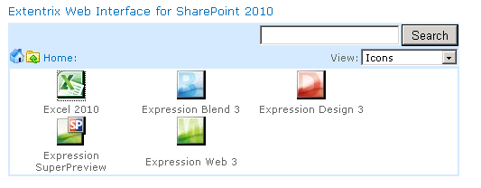

Figure 1: EWISP - Icons View

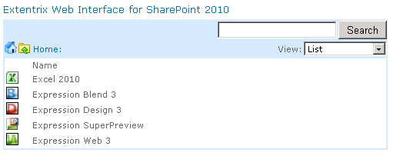

Figure 2: EWISP - List View

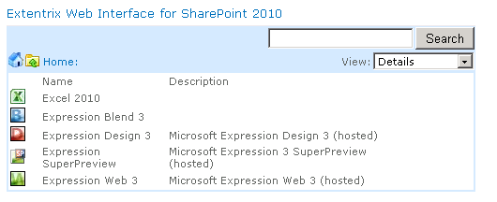

Figure 3: EWISP -Details View

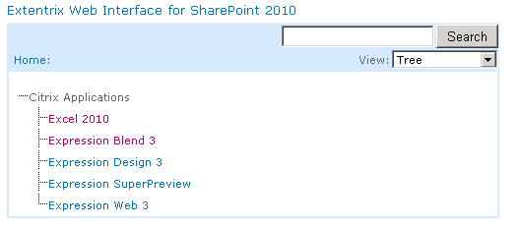

Figure 4 : EWISP - Tree View

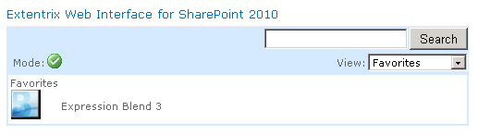

Figure 5: EWISP - Favorites View

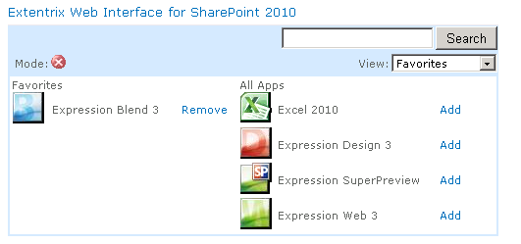

Figure 6: EWISP - Add favorites



Figure 7: EWISP – Search View

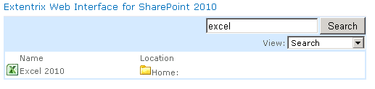

Figure 8: EWISP – Search Command

# Content Redirection

Extentrix WISP would allow you to open published contents using published applications by Citrix XenApp. This would relief you from having the application installed on your machine to open the document. Choose “Edit with Application Delivery by Citrix” to open the document using published application.

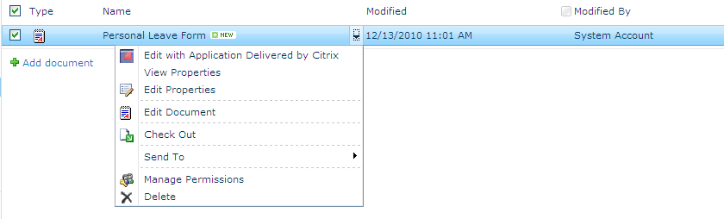

Figure 9: EWISP – Edit menu with Citrix option

To create new document, please use “Document Delivered by Citrix”.

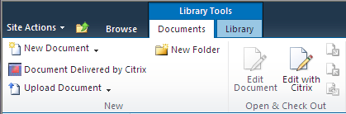

Figure 10: EWISP – Create new menu

# Customizing the Appearance of the Web Part

You can customize the appearance of the Extentrix Web Interface for SharePoint to match your requirements.

The Standard Web Part tool pane consists of the following options:

1. Appearance
2. Layout
3. Advanced options

These allow you to modify the size of a Web Part, where it appears on the screen, and whether it can be minimized or closed by a user. For more information, see your Microsoft SharePoint documentation.

Extentrix Web Interface for Microsoft SharePoint also includes Preferences and Style options.

## To modify the appearance of the Web Part

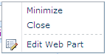

1. Click on the arrow for the EWISP web part.
2. Click **Edit Web Part**.
3. Choose from the following options:

|  |  |
| --- | --- |
| **To...** | **Do this...** |
| Change **height** of Web Part | Expand **Appearance** and select **Height** |
| Change **width** of Web Part | Expand **Appearance** and select **Width**. |
| Set logging preferences | Expand **Preferences** and select appropriate option. |
| Specify **body border width** | Expand **Style** and enter the width size in number of pixels **Body border width** box.  The default value is 2. |
| Specify **body border color** | Expand **Style** and enter the color for the border **Body border color** box. The default value is #D6E8FF. |
| Specify **body background color** | Expand **Style** and enter the color for the border **Body background color** box. The default value is #FFFFFF. |
| Specify **Toolbar background color** | Expand **Style** and enter the color for the border **Toolbar background color** box. The default value is #D6E8FF. |

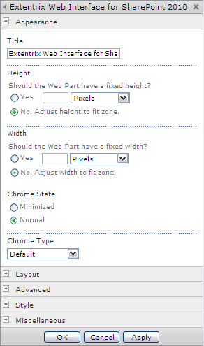

Figure 9: EWISP - Appearance Options

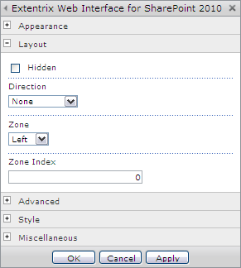

Figure 10: EWISP - Layout Options

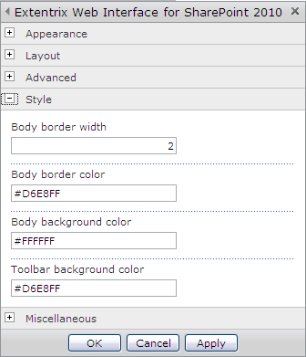

Figure 11: EWISP - Style Options

# About Extentrix

Founded in 2006, Extentrix Systems is a leading software development company specializing in virtualization and developing custom software solutions for Citrix and Microsoft customers. Established by former software engineers at Citrix, Extentrix have developed access solutions that simplify and speed users’ access to Terminal Services and Citrix platforms.